NEWTON’S SECOND LAW

- EQUIPMENT
1 connecting string  1 dynamics car  1 dynamic cart track  Newton’s 2nd Law Program  Lab Pro interface  - Power supply  - USB cord  Motion detector | Three 1/2 kg masses for cart  1 table edge pulley  1 set of masses  1 triple beam balance  1 50g mass hanger  1 25g mass

INTRODUCTION

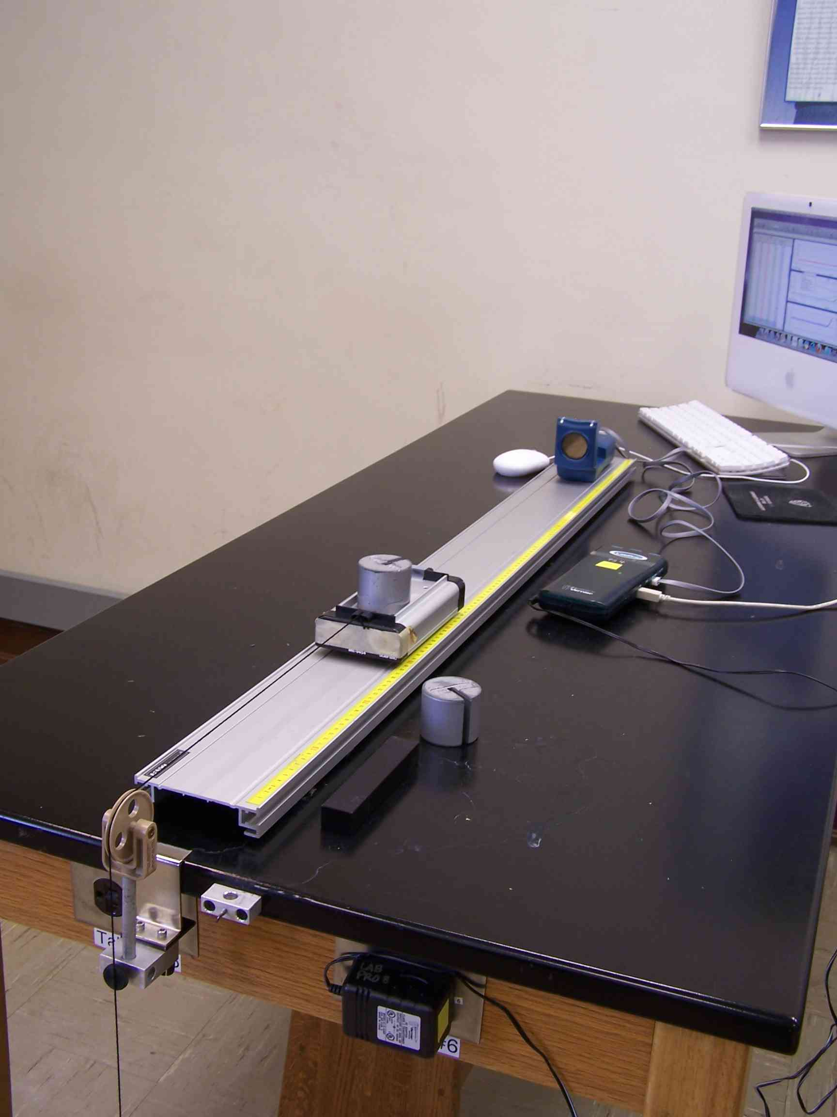
Mass 1
The purpose of this experiment is to examine the motion of an object under the influence of a uniform, or constant, force and to observe the effects of inertia on the motion.
Galileo discovered that objects change their state of motion when acted on by an external force, the velocity of the object changes at a constant rate. Galileo’s studies did not adequately explain the relationship between the inertial mass of an object and the force causing the motion. A century after Galileo’s discoveries, Isaac Newton was able to explain the relationship between force, mass and acceleration. Newton stated that the acceleration, or rate of change of velocity, is directly proportional to the unbalanced force acting on the object and inversely proportional to the mass of the object. This relationship (known as Newton’s Second Law) can be expressed as:
Figure 1

In this experiment you will observe the acceleration of a small cart pulled by a constant force. The force to move the cart is provided by the weight of a suspended mass attached to the cart by a string as shown in Figure 1.
The software used in this experiment generates a set of plots (graphs).

The screen will show 3 graphs: distance vs. time
velocity vs. time
acceleration vs. time.

d We remember that a curved line on a distance vs. time graph means that an object is accelerating.

t
The acceleration of the cart can be determined from the acceleration versus time graph, or by calculating the slope of the velocity versus time graph. The slope of the graph of velocity versus time is the acceleration of the cart. If the acceleration is constant, the slope is constant and a straight line can be drawn through the points.

V a

t t
Any object undergoing motion caused by a uniform force has constant acceleration. The object’s velocity is changing, but the rate of change (or acceleration) is constant. We can compare the slope of the velocity graph to the mean (or average) value of the acceleration graph, knowing that they should be equal.

The experiment will be repeated several times, first by varying the mass of the cart and then by varying the force pulling the cart. From the graph obtained for each run, you will investigate the change in the acceleration of the cart when the mass of the cart and the force pulling the cart are varied.

PROCEDURE:
A. Acceleration

1. The mass of the dynamics cart is ½ kg. Add ½ m kg to mass cart for a total of 1(one) kg. See Figure ____2 below.
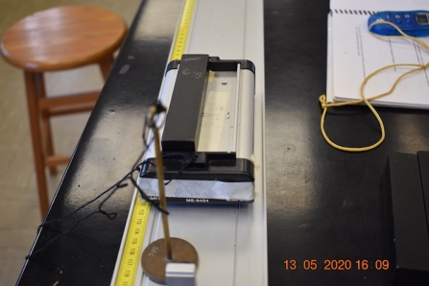
Figure 2. ½ kg Cart with ½ kg added

- Set the motion detector at one end of the table and the pulley at the other.
- Place the cart no closer than 40 cm to the motion detector, and position the string to run over the pulley. One partner should prevent the cart from moving while the other attaches a 50g mass hanger to the end of the string.

YouTube video of how data is collected can be found at

https://youtu.be/63J9qdMhQ7w

- Load the NEWTON’S 2nd LAW setup.
- Press COLLECT and release the cart. Do not allow the cart to hit the pulley.

This is data for trial one of data sheet

YouTube video of how to analyze graphs (in steps 6 & 7 below) can be found at

https://youtu.be/Db5-6XGmA2g

- Click the velocity graph, highlight the portion of the graph with a straight diagonal line, and find the equation of the line by clicking the R= button.
Remember: y = mx + b, and m = slope.

- Click the acceleration graph, highlight the portion of the graph that makes a straight line (this should be the same section that was diagonal for the velocity graph) and find the mean value of acceleration by clicking the STATS button.
The mean (i.e., average) for the acceleration graph should be equal to the slope for the velocity graph!

- Go to lab website and click on “Trial 1 plots” for acceleration data to fill in trial 1 of data table.
      - B. Variation of Mass
- Add 1 kg to the top of the cart. You have now increased mass by a factor of two. (What do think should happen to acceleration?) Repeat steps 5-7 in part A.
Go to lab website and click on “Trial 2 plots” for acceleration data to fill in Trial 2 of data table.

C. Variation of Applied Force
- Remove all additional masses until the cart has a mass of one kg (cart + ½ kg). The cart should have the same mass as in step one.
- Increase the value of the suspended mass by adding 50g for a total of 100g hanging mass. This will (approximately) increase the force pulling the cart by a factor of two (2).
- Repeat steps 5-7 in part A.
Go to lab website and click on “Trial 3 plots” for acceleration data to fill in Trial 3 of data table.

- Add 50g more to the hanger for a total of 150g. The hanging mass has now been increased by a factor of three (3).
- Go to lab website and click on “Trial 4 plots” for acceleration data to fill in trial 4 of data table.
Refer to this table for each trial!

Trial | Mass 1  (Cart + Mass) | Mass 2  (Hanging Mass) | Acceleration  (m/s/s)
1 | Cart+ ½ kg  Total mass = 1 kg | 0.050 kg
2 | Cart + ½kg  Total mass = 2kg | 0.050 kg
3 | Cart + ½kg  Total mass = 1 kg | 0.100 kg
4 | Cart+ ½ kg  Total mass = 1 kg | 0.150 kg

Name: Section:____
QUESTIONS
- From your velocity versus time graphs, can you conclude that the acceleration of the cart was constant in each case? State your reasons.

- When the mass of the cart was increased by a factor of two and the suspended mass held constant, what happened to the magnitude of the acceleration? Why?

- When the suspended mass was increased and the mass of the cart held constant what happened to the magnitude of the acceleration? Why?

- Relate the results of your experiment to the statement of Newton’s second law.

- If a cart has a weight of 10 N and is pulled by a constant 20 N force, what is the resulting acceleration? HINT: You must distinguish between mass and weight.

